CHECKOUT INVENTORY PREPARED FOR

7 CROWN LODGE
ELYSTAN STREET
LONDON
SW33PP

24TH JANUARY 2019 / 28TH JANUARY 2020

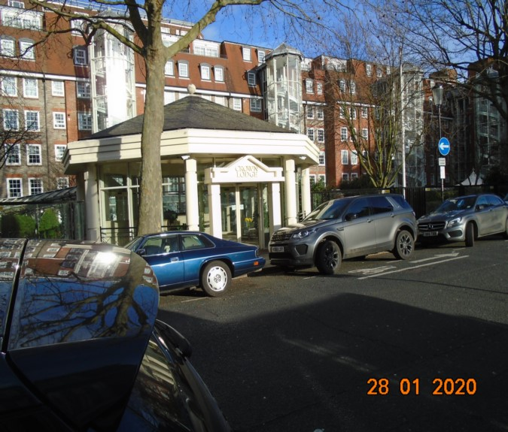

CLIENT: | London Central Portfolio
INSTRUCTED BY: | Liam Monaghan / Rory Halsey
JOB NO: | 2383 / 3601
REF: | MBPS-002 / MBPS-002
INSPECTED BY: | Richelle Lipton / Laura Sion
PROPERTY SIZE: | 1 Reception/ 2 Bedrooms / 2 Bathrooms - Furnished Flat

'WINDY RIDGE' 99 COWLEY HILL, BOREHAMWOOD, HERTS, WD6 5NA, TEL: 020 8 386 0950 - MOBILE: 077 67 647 647
EMAIL: info@inventorys.net www.inventorys.net
Registered No: 4263261 VAT No: 822 9322 12


Safety Disclaimer
This inventory report is prepared as an ‘as seen snapshot’ of the property and its contents at the time of the designated inspection and is compiled as a fair and accurate record for the properties internal condition and contents. This does not form any part of a valuation or structural report.

This inventory is compiled on the basis that all items listed are in good order and clean. Any defects or soiling are noted where appropriate. Where inspections are carried out and the tenants’ belongings are in situ, it can be difficult for clerks to differentiate to that belonging to the landlord or tenant. Should the report contain inaccuracies the clerk (Independent Inventories (UK) Ltd) will not be held responsible.

The clerk preparing the inventory is not an expert in electrical appliances, antiques, furniture style, fabrics, flooring, etc. All descriptions within this report are for identification purposes only in order that each item can be compared to its condition at the commencement of the tenancy.

Lofts and Cellars are not included unless they are converted and safely accessible. Contents will therefore not be noted or checked at check-in or checkout.

Plants and shrubs will not be itemised.

Belongings left by the landlord/agent in a locked room or outbuilding will not be inventoried and are the sole responsibility of the Landlord/agent. Items in garages/sheds such as garden equipment and tools will be inventoried, however tins of paint will not be itemised.

We do not undertake to move heavy items of furniture or access lofts, high-level cupboards, or any other inaccessible places. Contents which have been left in the above-mentioned areas, which have not been inventoried, are the sole responsibility on the landlord. We also do not undertake to open windows, but will confirm whether keys have been seen or not.

Any electrical appliances tested will be for power only and only where practicable. The clerks are not qualified electricians and will only confirm the visual condition of the electrical socket, wiring and or fitting as seen. Boilers, Heating Systems, Gas Fires, Water Supply and Radiators are not tested, and Independent Inventories (UK) Ltd will not take any responsibility for units left either on or off even if on automatic timers. Where smoke alarms and CO Detectors are tested this is for power only and should not be taken to mean that the alarms are in full working order. We only state their presence and cannot state the functioning of this equipment. No responsibility is taken for any damage or malfunction occurring during the testing of such alarms.

The relevant utility companies must check all meter readings, as we cannot be held responsible for any discrepancies. We are not held liable should meters not be located or inaccessible to read. For Health and Safety reasons we do not expect our clerks to access high level areas which involve using ladders/chairs.

The Fire & safety Regulations regarding furnishings, gas, electrical & similar services are ultimately the responsibility of the instructing principle. Where the inventory notes FFR label seen, this should not be interpreted to mean that the item complies with the furniture & furnishings (fire) (safety) (Amendments) 1993. It is a record that the item had a label as described or similar to that detailed in the Guide to the regulations as published by the Department of Trade & Industry, January 1997, (or subsequent edition), attached at the time the inventory was complied.

Blinds in the premises are visually checked. We are unable to verify that the blinds comply with child safety requirements of BS EN 131202009 + A1:2014 placed on the manufacturer, supplier and professional installation of internal window blinds

It is the responsibility of the landlord/managing agent/tenant to agree between themselves the accuracy of the report, and Independent Inventories (UK) Ltd should be notified within 7 days of receipt of the report of any discrepancies within the report.

GENERAL GUIDANCE NOTES

Independent Inventories do not have sight of tenancy agreements or other agreements made between the tenant, landlord and management company. As these are guidance notes only it is always advisable that the tenancy agreement is cross referenced. This report will indicate whether in our opinion the tenant is liable for the deterioration or whether it is considered fair wear & tear. Independent Inventories may suggest maintenance, cleaning or tenant’s liability at checkout, but the final responsibility of these suggestions will fall with the landlord or managing agent in respect of the original tenancy agreement. We do not suggest costs of any items, these should be sourced from the relevant contractors by the landlord or managing agent.

CLEANING

We recommend that a professional cleaning company is employed at the end of the tenancy, unless alternative arrangements have been agreed with the Landlord/Managing Agent. Receipts from professional cleaning and carpet cleaning companies must be present to the clerk at the checkout inspection.

If the standard of cleaning is not satisfactory most Landlords/Managing Agents will contract a cleaner and their charges will be charged to the tenant unless otherwise stated in the tenancy agreement.

DECORATION

It is accepted that during the course of the day to day living scuffs will appear on walls and woodwork. However, should the marks be found to be excessive charges will be made to you the tenant, unless otherwise stated in the tenancy agreement.

LIGHTING

If the lights are working at check in then it is normal, if lights are not working at checkout, for these to be the responsibility of the tenant to replace bulbs or to be charged accordingly, unless otherwise stated in the tenancy agreement.

GARDENS/PATIO

If the standard of the garden/patio is found to be untidy compared to the start of the tenancy the Landlord/Managing Agent are entitled to employ a contract gardener and the charge will be made to you the tenant, unless otherwise stated in the tenancy agreement.

MAINTENANCE ISSUES

We recommended should any maintenance issues arise you contact the Landlord/Managing Agent immediately so they can deal with the matter. Should we recommend items require maintenance once a property has been checked out, this is purely stating that an item will require fixing/attention, we are not advising as to whose responsibility this and your tenancy agreement will need to be checked.

CHANGES TO PROPERTY

We recommend that if you wish to make any changes to the décor or remove any of the Landlords belongings you contact the Landlord/Managing Agent for permission and have this confirmed in writing to ensure there are no discrepancies at the end of the tenancy.

TENANTS INFORMATION FOR CHECKING OUT OF PROPERTY

It is important at the checkout that:

- All cleaning should be completed prior to the checkout appointment as per the tenancy agreement.
- All personal items must be removed prior to the check out.
- All items should be in the same location as per the inventory, any stored items should be unpacked and also returned to the same location.
- If the Inventory clerk has to search for items or you still have belongings in the property to be removed this will result in additional charges being made to the tenant.
- All beds should be left unmade with the linen folded. Bedding & towels should be cleaned & ironed where relevant.
- All food items should be removed, freezers defrosted & doors left open & electricity turned off.
- All light bulbs etc. should all be in working order as at check in.

The property should be left in a clean and tidy condition especially carpets, curtains, windows, upholstery appliances etc. We would suggest that you refer to your tenancy agreement in this matter.

If you are not ready to leave it may not be possible to carry out the checkout. In this case a return visit will be necessary resulting in a cancellation charge.

All keys to the property must be handed over at the time of checking out to the Inventory clerk or alternatively to the agents prior to the checkout taking place.

The Inventory Clerk acts as an independent and reasonable body and will avoid unnecessary criticism or derogatory comments when compiling or checking the Inventory.

At the termination of the tenancy the inventory will be checked and any obvious or significant discrepancies will be reported to the Managing Agent/Instructing Principal. This report will indicate whether in our opinion the tenant is liable for the deterioration or whether it is considered fair wear & tear. Normal fair wear and tear will be assessed on the lengthy of the tenancy and type occupancy.

INDEX
PAGE

UTILITY READING & SAFETY EQUIPMENT | 1-4
KEYS | 5-6
GENERAL SUMMARY | 7
INSTRUCTION MANUALS | 8
ENTRANCE HALL | 9-19
BATHROOM 1 | 20-26
BEDROOM 1 | 27-35
BEDROOM 2 | 36-48
EN-SUITE | 49-56
RECEPTION | 57-68
KITCHEN | 69-88
DECLARATION AT CHECK IN | 89
ADDITIONAL AMENDMENTS | 90
CHECK IN SCHEDULE OF CONDITION | 91-93
SIGNED SCHEDULE OF CONDITION AT CHECKOUT | 94-95

UTILITY READINGS / KEY LIST& INSTRUCTION MANUALS

ELECTRIC | GAS | WATER
METER NUMBER:  S65A 40930 | METER NUMBER:  469 674 5 | METER NUMBER:  0102 unable to read rest
READING:  95429 | READING:  1319 | READING:  00416
LOCATION:  Cupboard on landing right of entry | LOCATION:  Kitchen base unit | LOCATION:  Kitchen base unit

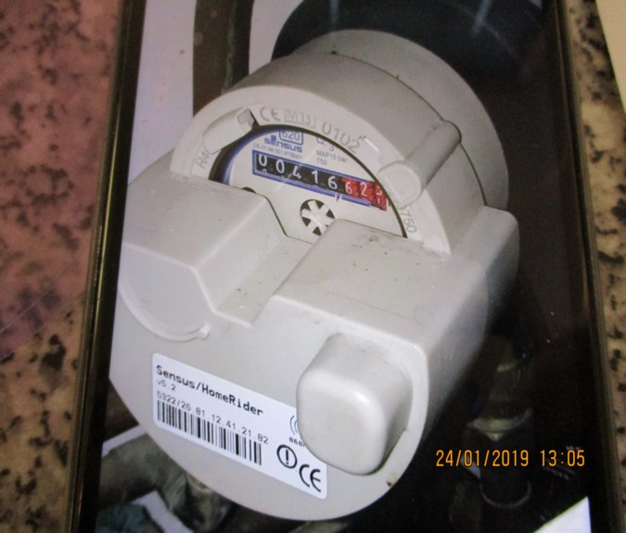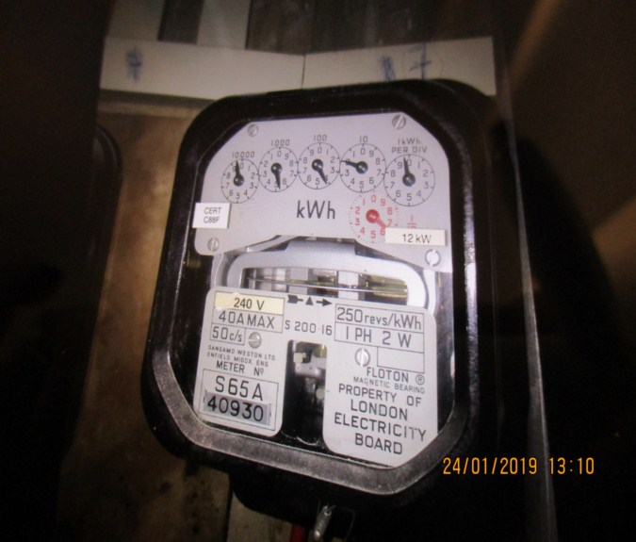

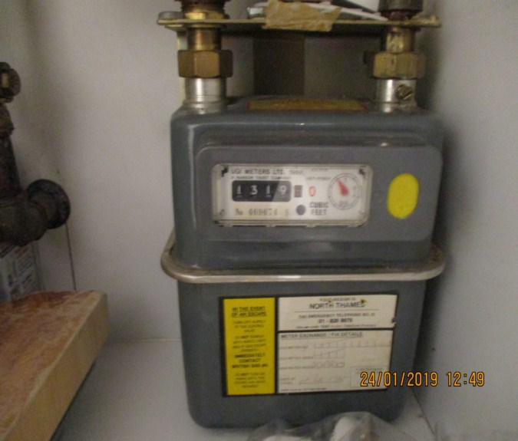

ELECTRIC | GAS | WATER
METER NUMBER:  S65A 40930 | METER NUMBER:  469674 Sink | METER NUMBER:  0102 unable to read rest
READING:  08228 | READING:  1672 | READING:  00688.74
LOCATION:  Riser cupboard outside flat door | LOCATION:  Under sink in kitchen | LOCATION:  Under sink unit
SUPPLIER:  Key required from porter | SUPPLIER: | SUPPLIER:  Unknown

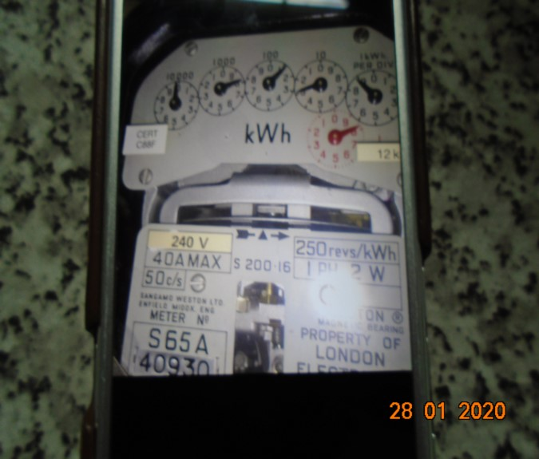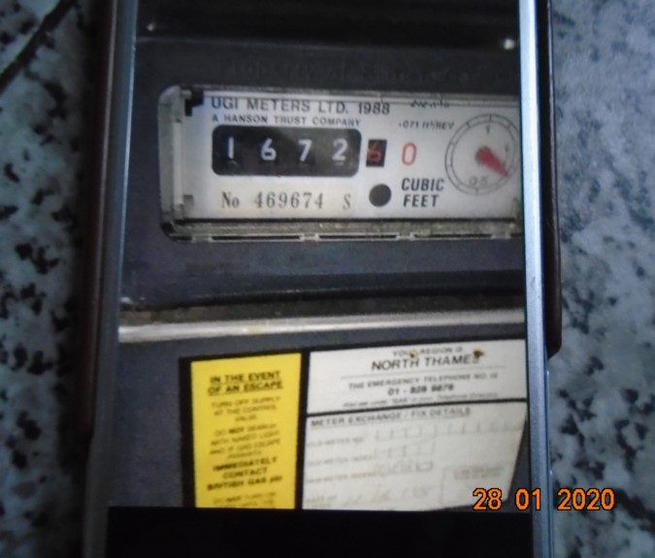

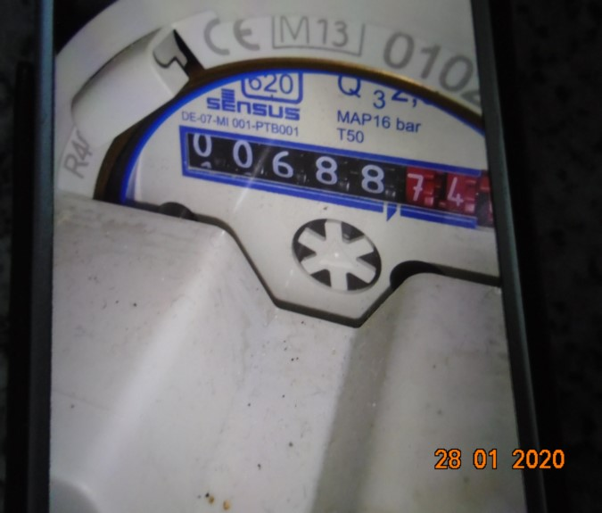

LOCATION OF:

STOP COCK | Kitchen base unit
FUSE BOARD | Flat hall cupboard
ALARM PANEL  This has not been tested | N/a | MAKE:

FIRE SAFETY

SMOKE ALARM 1 | Location: Hall  Button pushed, Tested and working  Expiry date: Label not seen
CARBON MONOXIDE ALARM | Tested and working order  Hall wall

KEYS AT CHECKIN | KEYS AT CHECKOUT
KEY TYPE / SERIAL NUMBER / QTY | KEY TYPE / SERIAL NUMBER / QTY
1 + 1 x Fob flat electric riser cupboard 1 | 2 x Keys fob and cupboard keys returned to porter
 | 2 x Sets of 2 x keys plus and 1 x fob returned to LCP
KEYS RECEIVED BY: collected and returned to Concierge  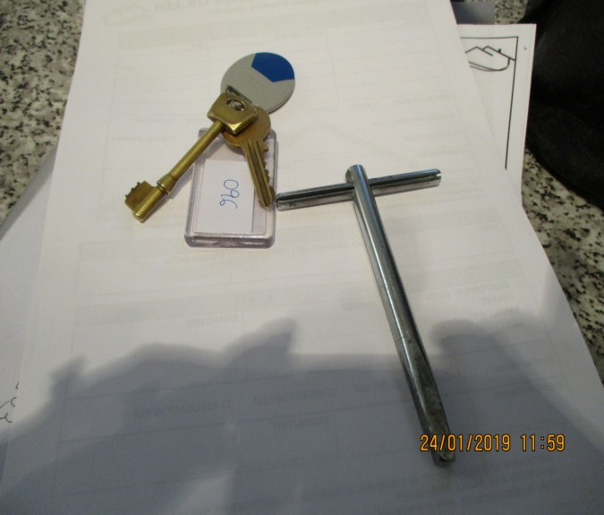 | KEYS RETURNED TO: Agent LCP  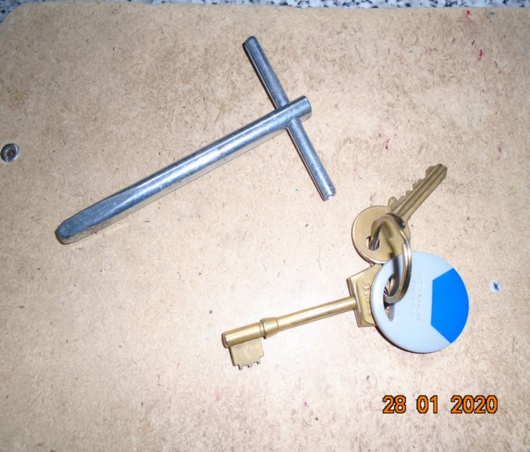  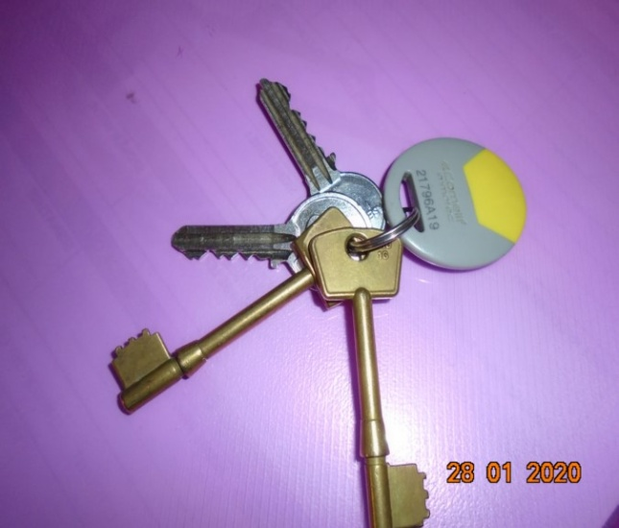

GENERAL SUMMARY

ITEM | CHECKIN NOTES | CHECKOUT NOTES

GENERAL CONDITION |  | Professionally cleaned for start of tenancy | Professionally cleaned for end of tenancy  Advised LCP cleaned but tenant had separate Cleaner for carpet
ODOUR |  | N/A
DECORATIVE ORDER / WOODWORK |  | Good order  Defects as noted | Defects as noted  Woodwork scuffed/chipped
FLOORING |  | Professionally cleaned for start of tenancy  Good order  Defects as noted | Vacuumed for end of tenancy  Carpet in use
CURTAINS / BLINDS |  | Professionally cleaned for start of tenancy  Good order | Vacuumed in situ for end of tenancy  Defects as noted
BLIND REGULATIONS
UPHOLSTERY |  | Professionally cleaned for start of tenancy  Good order  Defects as noted | Defects as noted  Requires further vacuum  Stained as noted
FFR LABELS | FFR labels seen  FFR labels not seen as noted
LINEN | None provided |  | In use  Stored in chest
LIGHTS | Bulbs missing/ not working as noted |  | Number bulbs not working

KITCHEN / APPLIANCES | All clean order  All appliances power tested  Fridge / freezer left open power on  Light not working | All appliances power tested – unable to open over door and overhood loose not tested  Fridge / freezer left open power on  Defects as noted
BATHROOMS/  WC | Clean / Water outlets tested and working  Bath/ shower not tested | Clean  Water outlet tested and working  Defects as noted
WINDOWS | Fitments complete  Clean to interior / exterior | Fitments complete  Defects as noted
GARDEN /  TERRACE | N/A | N/A

MANUALS SUPPLIED AT  CHECKIN | MANUALS RETURNED AT  CHECKOUT
APPLIANCE / MAKE | APPLIANCE/MAKE
BOILER
WASHer dryer
INTERCOM

*N.B – Heavy items will not be moved or inspected behind/under, for health& safety reasons. We will not be held liable should any damages/stains/marks be found during the tenancy in these areas. Should the occupant find any of the above they should, inform the landlord/agent immediately and if/where possible take photographic evidence and pass to the relevant parties.

 This camera symbol throughout the Inventory check in/out indicates where a photo has been taken. Photos can be found at the back of each room in the report with the relevant headings.

ENTRANCE HALL

Door | Exterior Door Frame  Painted white
 | Exterior Door  Painted Grey  Chrome spy hole  Brass and stainless steel ASEC lock | 1. Minor chips to edge and painted over defects  2. Low level scuffs
 | Interior Door Frame  Painted white | Mid level chip left hand side
 | Interior Door  Painted black  Brass barrel lock  Black painted over Chubb  Chrome spy hole  Brass letterbox  Brass return screw | 1. Letterbox has some black , white paint marks and scratch marks  2. Brass tarnished  Small chip above spyhole  Odd chips to tc
ENTRANCE HALL

Entrance Hall | L shaped
Ceiling and Coving | Painted white | 1. Paint seems to be a bit streaky in places  2. Cracking by spot and vent facing wall bedroom 2  3. Scuff by section forward of cupboard on lintel

ENTRANCE HALL

Walls | Painted grey | High level no defects
Back Wall
Houses the door

 | Left Hand Side Wall  2 x Chrome fuse switches  1 x Chrome single switch  Entrance to bathroom  Entrance to hallway cupboard  Entrance to bedroom one  Blank between bedroom one and bedroom two | 1. White paint mark between bedrooms-touch up seen paint not matching  2. Indent and blue marks under switch left of bathroom  3. General usage mid/low level  4. Low level angle wear  5. 1 x Chip  6. 1 x Scuff  7. Minor soiling  8. Curved indent  9. Angle wear mid-level  10. Mid-level touch up  11. Impact mark from entrance door handle – no door stop

ENTRANCE HALL

Walls contd.., |  | Wall to left hand side bathroom entrance paint chips from entrance door handle striking wall  Brown liquid drips mid-level  Further chips to left hand wall  1 x tear to lining paper
 | Front Wall  Starts bedroom two  1 x Chrome switch  1 x Chrome single socket  Entrance to reception | 1. Mid lower level scuffs and usage  2. Low level chips
 | Right Hand Side Wall  1 x Cream doorbell plastic fitting at high level  Entrance to kitchen  1 x Metal vent  1 x Comelit entry phone system mounted on white plate  1 x Chrome single socket  1 x Chrome single switch | - Entry phone not tested  - Mid level scuff facing wall entry  - Patchy section under entry phone  - Low level dark scuff forward of entry  5. Dark scuff marks mid-level  6. Carbon monoxide alarm left hand side kitchen entrance

ENTRANCE HALL

Woodwork | Painted white  Lightwood beaded trim | 1. Some scuffs  2. Cable tacked to top in places
Flooring | Lightwood laminate floor boards running right through | 1. Very scattered minor heel indents, mainly seen two at entry  2. Couple of edge chips to the laminate between bedroom one and bedroom two  3. Scuff forward of entry  4. General usage
Lighting | 7 x Metal casing spotlights | 1. Some paint chips around the light fitting in front of the cupboard  1 x not working  1 x taken little longer to work
Vent | 1 x Off white vent | 1. Paint marked  2. Bit shaded

ENTRANCE HALL

Windows | None
Blinds | None
Heating | None
Alarm | 1 x Nighthawk alarm on ceiling outside bathroom and kitchen area | Tested and working
Cupboard | Cupboard Door Frame  Painted white | - Appears to be in good order  - Clean
 | Cupboard Door  Painted black  1 x Space for a key- but no key seen | Scuffs seen

ENTRANCE HALL

Cupboard contd.., | Cupboard Interior  Houses the water tank  Airing cupboard  Ceiling is painted white  Interior walls are painted grey  Assorted pipe works fitted to right hand wall  Flooring is plywood floorboard that the water tank rests on  1 x Vinyl silk washable 5 litre paint can  1 x Large black water tank  1 x Hot water tank with mustard coloured casing | 1. Wall have some unfinished areas towards centre, not complete  2. Unable to inspect the back wall  3. Some water marks and drip marks to both sides of the walls  4. Appears patchy  5. Plywood flooring unfinished, in use, aged order  6. Floor underneath plywood is unfinished  7. Couple of minor assorted  8. Grubby marks to ceiling  Water stain to ceiling

ENTRANCE HALL

Cupboard | Cupboard Left Hand Wall  1 x Freedland white plastic black on left hand wall  1 x White plastic fuse switch  1 x Honeywell hot water temperature control  4 x Further White plastic fuse switches  Slatted wooden shelf  1 x Cream plate  Assorted cables  Assorted pipe work seen  Grey bucket  Mops and miscellaneous items | Fuse switch very shaded  Further fuse switches all very marked  Screws missing from cream plate  Not fitted  Not inspected
 | Mop | In use
Unit | 1 x white laminate table with shelf shoe storage

CHECKOUT PHOTOGRAPHS

BATHROOM 1

Door | Exterior Door Frame  Painted white | 1. Couple of minor marks  Odd chip to low level  Veneer lifting low level to door exterior
 | Exterior Door  Flush painted black door  1 x Chrome lever handle  1 x Chrome reverse for turn lock  1 x Lightwood threshold bar | 1. Worn to the leading edge at high level to mid-level  2. Threshold bar chipped to edge especially towards the interior side– now appears glue/replaced – glue residue  3. Couple of light nicks to frame left hand side  4. Slightly patchy
 | Interior Door  Flush wood painted black  Chrome lever handle  Chrome turn lock  1 x Chrome single hook | 1. Lock in working order  2. Hook properly fitted  Chip to bottom edge  Stiff

BATHROOM 1

Ceiling | Painted white | 1. Seems to be in good order  2. Light cracking between vent and shower  3. Few spots above shower  Extractor vent in ceiling working order
Walls | All white square tiles  1 x Mid-level chrome grout runner running right through | Grouting seems to be in fair order  Exception of discoloured grout in shower area
Back Wall
Houses the entrance door

Left Hand Side Wall
Houses the heating system

Houses the shower to be described separately

Front Wall
Houses part of the shower

Houses chrome shaver socket

Houses vanity door with mirror

Houses basin

BATHROOM 1

Walls contd.., | Right Hand Side Wall  Houses chrome towel rail  Houses single panel radiator | Chrome towel rail in good order (very loose)
Woodwork | White tiles | Appears to be in good order  Loose at corner shower base
Flooring | White tiles  1 x Chrome with black seal to front edge doorstop fitted | 1. Seems to have some grout discolouration  2. Door stop appears to be in good order
Contents

Toilet | Ideal Standard  White plastic seat and lid  Flush is chrome lever handle in tiled cistern section | 1. Cistern appears to be in good order – not inspected  2. Flush tested and working  3. Seat does not fit pan
Toilet Brush | 1 x White toilet brush and holder | In use- not examined
Lights | 3 x lights in ceiling | All working
BATHROOM 1

Shower Cubicle | Glass sliding doors  Chrome frame  White tray  White tiles at base  Chrome waste to the tray  2 x Knobs for taps control  Shower head  White tiles to the surround | 1. Appears to be in good order  2. Clean order  3. General usage  4. Shower not tested  5. Scratched and in use  Inner chrome is stained for sliding door  Tiles is opening front edge  Not tested  Approximately 3 inch chip mark to back edge
Basin | Chrome circular basin  Inset into an obscure glass  Chrome frame  Integrated chrome towel rail  Chrome hot and cold mixer tap  Pop up plug | 1. Tap is tarnished  2. In use and in good order  3.Water tested and working and clean order  4. Some scale to join of glass and chrome frame  5. Discoloured beneath bowl and heavy corrosion

BATHROOM 1

Vanity Cupboard | Mirrored door  2 x Glass shelves  1 x Tiled base shelf  Tiles to the surround | 1. Tiles are in good order  2. Hairline cracks to base  Light silvering to edge
Heating | Cream coloured single panel radiator | Rusting to top left hand side and right hand side
Items Seen | 1 x Free standing metal stand  Loo roll holder
Additional items | Artificial flower in basket  Freestanding rattan drawer unit with 6 x drawers  Small stainless steel pedal bin

CHECKOUT PHOTOGRAPHS

BEDROOM 1

Door | Exterior Door Frame  Painted white | 1. Appears to be in good, clean order  2. Few low level chips left hand side
 | Exterior Door  Single panel door painted black  Chrome lever handle  Chrome threshold bar  Fire chain intact | 1. In good order  2. Base chips  White paint to opening edge low level
 | Interior Door  Painted black  Chrome lever handle | 1. Appears to be in good  order  2. White rubs to finish
 | Interior Door Frame  Painted white | Light scuff to upper level  Minor chip to low level
Ceiling and Coving | Painted white | 1. Good order  Scuff to coving above back wall

BEDROOM 1

Walls | Painted light grey
 | Back Wall  Houses the entrance door  1 x White plastic double socket point  1 x Chrome double socket point | 1. Unable to inspect behind the bed  2. Old defects under  3. 4 x Circular plaster pops showing through  Grubby appearance mid level  Furniture scuffs
 | Left Hand Side Wall  1 x Chrome double switch point  In-built wardrobe | General usage mid/low level  Further usage  Angle chips
 | Front Wall  2 x Chrome double socket points  1 x Chrome blank plate  1 x White plastic 3amp point | 1. Light usage  2. A few mid level scuffs to angle  3. Small dent low level left hand side
 | Right Hand Side Wall  Houses the window  Houses the radiator | Mid to low level light marks
Woodwork | Painted white | 1. Scuff mark to the left hand side of the in-built wardrobes approximately 3” and right hand side  2. General usage  Additional scuff to skirting

BEDROOM 1

Flooring | Carpets appear to be cream coloured  1 x Chrome and black rubber doorstop | 1. Worn to tread  2. Door stop loose with wooden base showing through  3. Bit shaded  4. Some pressure marks from furniture.  5. Few further marks and light usage  6. General usage  1 x large brown stain forward of unit
Lighting | Chrome rack with 4 x spotlights | All working order
Heating | White panel radiator  Taps are complete | Some edge ships on the left hand side and the right hand side  Right hand side valve missing
Window | UPVC style window  Double glazed  1 x Grey metal handle | 1. Freshly clean to the interior  2. Handle slightly scratched  Sill paint cracking

BEDROOM 1

Window Sill | Painted white | 1. Some odd under scuff marks towards the right hand side front edge of the sill  2. Cracking especially to right hand side and under window  3. Paint lifting  1 x brass safety hook attached edge of window sill
Blinds | Wooden venetian blinds | 1. Seem to be in fair order  2. Tested and working  Left hand side upper level hanging slat  Odd scuff to white pelmat  Anchor is seen
In-Built Wardrobes | In-Built Wardrobes Exterior  Frame painted white  Folding double mirrored doors  1 x Brass handle towards the centre at mid level  Doors open and close on a track | 1. Handle is tarnished and loose  2. Mirror is silvering to the top edge left hand side  3. Tiny chip to left hand mirror door at upper level right hand side corner

BEDROOM 1

Wardrobe contd.., | In-Built Wardrobes Interior  1 x High level chrome rail at left hand side  1 x Mid level chrome rail at right hand side  4 x Shelves  Carpet for flooring  Painted white to interior  Assorted hangers  Philips box- not inspected interior  1 x white electric fan  White storage basket | 1. Appears to be generally in good order  2. White metal basket loose on floor  3. General usage
Chest | Wooden chest (matching chest in reception) | In use and ring marks to top
Bedside Lamp | Cream ceramic base with cream shade | Stain to shade interior  Tested and working
Floor Light | Black tripod floor lamp with black shade | Tested and working

BEDROOM 1

Bed | 1 x kingsize bed with wooden base + ratten headboard  Light blue padded mattress  1 x White duvet and cover  2x Pillows and white pillowcases  Brown blanket  White fitted sheet | Appears new
Chest of drawers | Narrow wooden chest of drawers  5 x Drawers | 1cm Chip to bottom drawer facia right hand side
Door stop | Grey door stop wedge
Items Seen | 1 x white pedestal fan in wardrobe | Not seen
Silver dimpled ornament

3 x assorted faux flowers / plant small holders

Chrome glass mesh candle lantern

Chrome clock

CHECKOUT PHOTOGRAPHS

BEDROOM 2

Door | Exterior Door Frame  Painted white  Lightwood threshold bar | 1. Cable clip to the right hand side at high level and the left hand side  2. Basically in good order  3. Chips to the threshold bar towards interior section  4. Cracking left hand side upper level
 | Exterior Door  Painted black  Chrome lever handle  Circular collar  Fire chain | 1. Low level several white scuff marks caused by door stop  2. Base chips to door heavier at leading edge  3. Couple of further edge chips mid/low level
 | Interior Door  Painted black  Chrome lever handle | Light base chips by leading edge
 | Interior Door Frame  Painted white | Appears to be in good order
Ceiling and Coving | Painted white | 1. Appears in good order  2. Tiny scuff forward of wardrobes

BEDROOM 2

Walls | Painted light grey | Paint patch visible near bathroom
 | Back Wall  Entrance from the hallway  1 x Chrome double switch point  1 x Chrome single switch  1 x Chrome satellite and TV point  1 x Chrome double socket point  Doorway to the en-suite | 1. Some old defects under  2. Generally good order  3. Angle chips  4. A few scrapes mid level left of en Suite- appears possible painted over  5. Stress cracks
 | Left Hand Side Wall  Houses the windows  Houses the radiators | 1. Touch ups under windows  2. Some low level usage
 | Front Wall  2 x Chrome double socket point  2 x White plastic 3amp points  1 x Chrome blanking plate | 1. Seems to be in good order  Several touch ups
 | Right Hand Side Wall  Bank of wardrobes  High level painted grey | In good order

BEDROOM 2

Woodwork | Painted white | 1. Appears to be in reasonably good order  2. Scuffs facing wall entry and left of ensuite  3. Scuff left hand side under window  Joint showing left hand side corner  Few scuffs left hand side of bathroom
Flooring | Cream coloured carpet | 1. Not new  2. Seem a bit worn to thread  3. Slightly shaded on entry area  4. Scattered marks  5. Generally in use  6. furniture pressure marks  7. Further usage  - Grey spots forward of window  Black stain right hand side behind door  Scattered stains

BEDROOM 2

Lighting | 1 x Brushed steel metal light fitting  4 x Light bulbs | All working order
Heating | Single double panel radiator  Painted white  Caps are complete | Minor low-level marks
Windows – Description starting from left hand side | 2 x Windows
 | Window 1  Double glazed  White frame  Grey lever handle  Open both horizontally and vertically | 1. Casing to left hand side window seems slightly loose  Paint crack around frame  Odd scuff to low level casing
 | Window 2  Double glazed  White frame  Grey lever handle  Open both horizontally and vertically | 1. Seems to be a faint scratch mark to the outside panel high level left hand side  2. Scuff to reveal left hand side  Paint crack around frame

BEDROOM 2

Window Sill | Painted white  Mould stains under window | 1. Few light scratch marks seen on left hand side.  2. Right hand sill cracking  3. General usage  Stain left hand side of right hand side window sill
Blinds | Now 4 x cream fabric curtains  Approximately 12/ 14 inch below sill | Good order  Curtains off hooks in places

BEDROOM 2

In-Built Wardrobes | 4 x Double doors  1 x Single door  Mixture of mirrored doors and opaque glass doors
 | Wardrobe 1  Mirrored Double Doors  Chrome poles  Interior is lightwood panels to the ceiling, walls and floor  2 x Ceiling spotlights with chrome surround  1 x White plastic fuse switch  1 x Lightwood hat shelf  1 x Grey rail  2 x Grey metal shoe stands  Base shelf  1 bronze stem lamp with brown shade | 1. Left hand side door centre hinge unattached  1 x screw missing centre hinge right hand side door  Door unable to fully open due to bedside table  Light possible not working  Not tested shade is torn

BEDROOM 2

In-Built Wardrobes | Wardrobe 2  Double Doors  Opaque glass  Grey metal frame surround  2 x Spotlights at high level  1 x Metal rail at high level  1 x Metal rail at mid level  1 x Lightwood shelf | 1. Lights working  2. Some scuff marks to high level of obscure doors to the frame  3. Scuffs at mid-level by pull section  4. Glass a bit worn  5. Right hand pull loose and left hand side pull of double door
 | Wardrobe 3  Mirrored door  Lightwood laminate panels to the interior  1 x Ceiling spotlights with chrome surround  4 x Shelves  Base shelf | 1. In good order  Scuff at mid level by pull  Working order

BEDROOM 2

In-Built Wardrobes | Wardrobe 4  Opaque glass with metal frame surround  Lightwood laminate panels to the interior  2 x Chrome spotlights  1 x Chrome rail  1 x Mid level lightwood shelf  4 x Grey pull out drawers  Assorted hangers | 1. Pulls to both are slightly loose  2. Some odd spot marks to the opaque glass door, left hand side  3. Marked on the right hand side of left hand side cupboard  4. 1 x Screw missing to right hand pull and left hand side  Appear not working

BEDROOM 2

In-Built Wardrobes | Wardrobe 5  Double doors  Mirrored doors  Chrome pulls  2 x Chrome spotlights  1 x Hat shelf  Divider  1 x Chrome rail  Right hand side just has base shelf  Selection of hangers  1 x jade blanket  Blue + white carpet sweeps  Wooden venetian blind | 1. Back panel to the right hand side is loose and nails are evident  2. Chrome spotlights not working  Hat shelf is bowing

BEDROOM 2

Bench | 1 x Bench  4 x Dark wood legs | 1. Few brown spot marks seen to one side. Please see photo for reference  2. Runner has odd orange stain and white marks seen.  3. Bench well in use and scattered stains

BEDROOM 2

Linen | 4x Pillows + cases  1 x Mattress protector | Not seen | T
Door stop | Chrome door stop wedge | Not seen | T
Items Seen | 1 x Fitted sheet  1 x Duvet and white sheet  1 x lavender plant in white pot + saucer | Not seen | T

CHECKOUT PHOTOGRAPHS

EN-SUITE

Door | Exterior Door Frame  Painted white  1 x Chrome runner threshold strip | 1. Appears to be in good order  2. Runner has few scratch marks  3. A few small chips
 | Exterior Door  Painted black  Chrome lever handle  Chrome reverse for swivel lock | A few scratches and paint spots  Edge chip to base  Chip to leading edge upper level and low level
 | Interior Door  Painted black  Matching chrome handle  Turn knob  1 x Hook | A few paint chips  Handle slightly loose
 | Interior Door Frame  Painted white | Appears to be in good order  Minor chip to low level
Ceiling | Painted white | Stress crack forward of window  Left hand side paint crack window
EN-SUITE

Walls | Part cream marble tiles  Part painted magnolia | Some light splash marks to back wall low level
 | Back Wall  Houses the entrance door | 1. Light general usage  Scattered scuff to wall  Paint brush marks visible upper level
 | Left Hand Side Wall  Houses the water system  Houses the basin  Houses part of the shower | Appears to be in good order
 | Front Wall | Patchy sealant around bath appears good order
 | Right Hand Side Wall  2 x Wall mounted chrome towel holders  1 x Double panel radiator, caps complete | 1. Odd marks to the left hand side cap  2. Paint cracking above radiator  Paint brush marks visible upper level
EN-SUITE

Woodwork | None
Flooring | Large cream ceramic square tiles | - Ingrained marks  Grouting slightly discoloured  Rust type staining right hand side of WC
Lighting | 4 x Inset spotlights | All working order
Window | Double glazed UPVC style window  Obscure with large panel at high level  2 x Smaller panels at low level  Metal runners in-between | Clean to interior
Contents

 | 2 x Glass shelves to left hand side wall  In recess area  2 x various size glass vessels  1 x white cup + saucer  1 x metal candle | Slightly loose
EN-SUITE

Shaver Socket | 1 x Chrome shavers only socket
Toilet | 1 x Toilet  White plastic seat and lid | 1.Flush tested and working
Mirror | 1 x Self framed Mirror | 1. Silvering to low level
Basin | Hot and cold mixer tap  Waste and push plug | 1. Tap and waste is tarnished  2. In used condition  3. Tested and working
Vanity Unit | White vanity unit  1 x Drawer with long chrome handle | Light usage to interior  Veneer wavy lifting left hand side  Chipping to base edge

EN-SUITE

Bath | 1 x White coloured bath panel  1 x White plastic bath  Hot and cold mixer tap  Pop up plug  1 x Chrome shower hose  1 x Shower riser  Microphone shower head  Glass screen and chrome handle/ towel rail | 1. Plug in working order  2. not tested  3. Wall below shower heavily marked/ stained  Bath usage marks to interior  Wear to splash strip low level
Toilet brush and holder | Plastic toilet brush and holder | 1. Not closely inspected  2. In use
Bin | Wicker bin  White plastic bin

EN-SUITE

Toilet roll holder | Free standing toilet roll holder
Hair dryer | Hair dryer in box  1x grey and white | Dryer not closely inspected  Not tested
1 x white metal filing saucer with candle

2 x chrome rails above radiator right hand side

1 x white ceramic bowl

1 x white ceramic pot

1 x glass small vase

CHECKOUT PHOTOGRAPHS

RECEPTION

Door | Exterior Door Frame  Painted white | 1. In good order  2. Clean to the top
 | Exterior Door  Single panel door painted black  Chrome lever handle to the far right hand side  To left hand side it is folding black painted, double doors  Bolts at high level to secure folding doors | 1. Doors catch on the floor  2. Few minor marks  3. 2 x Low level chips
 | Interior Door Frame  Painted white | Appears to be in good order
 | Interior Door  Single door  Lever handle | 1. Single door on far right in good order  2. Folding doors also in good order  3. 1” Chip mid-level to interior folding door
RECEPTION

Ceiling and Coving | 1 x Beam  Painted white | 1. Appears to be in good order  2. 1 x scuff to beam
Walls | Painted grey colour  1 x Chrome door stop with black rubber tip behind the door
 | Back Wall  1 x Double chrome switch  House entrance door  1 x Chrome TV point | 1. Light scratching below  Switch  - Light general usage  - Paint touch up UI slide
 | Left Hand Side Wall  1 x White plastic 3amp point  2 x Chrome double socket points  1 x Very long cream coloured radiator, possibly a triple panel, caps complete | Radiator not closely inspected behind sofa  1 x white plastic hook  Rusting to low level both sides (ends)
 | Front Wall  Houses the windows | 1. Unable to inspect walls properly due to furniture  2. Has some old defects under  3. Generally good order

RECEPTION

Walls contd.., |  | 2 x drilled holes right hand side of right-hand window
 | Right Hand Side Wall  2 x Plastic 3amp points  2 x Chrome double socket points  1 x Cream coloured ‘Honeywell’ temperature control  1 x Off white FM satellite and TV point | Paint patch visible wrong shade  1 x white picture hook upper level
Woodwork | Painted white  Wooden beaded trim | 1. Some white paint marks  2. Appears to be in generally good order  3. Unable to inspect properly behind furniture  4. Some light scuffs

RECEPTION

Flooring | Lightwood laminate floorboards  White fur throw | 1. Appear to be in fairly good order  2. No heel indents seen  3. Some scratch marks seen towards the centre near the armchair  4. Freshly cleaned  5. A few light scuffs and scratches and further scuffs  6. Gapping to centre  7. Slight furniture scratches and scuffs generally around furniture  8. Not inspected under furniture  9. Ends of boards appear to be lifting slightly  10. ½” chip forward of windows
Lighting | 2 x Brushed steel racks  4 x Bulbs to each | All working order

RECEPTION

Heating | Radiators have already been described in walls section
Window | Window 1  UPVC style window  Metal grey handle | 1. Clean to the interior
 | Window 2  UPVC style window  Metal grey handle | 1. Clean to interior
Window Sill | Window Sill 1 and 2  White painted window sill | - Cracking at rear  - Chip to sill window 2  3. General scratches to both
Blinds | Blinds on Window 1  Wooden venetian blind with 3-pulley cords and 4-acorns | 1. In working order
Blinds | Blinds on Window 2  Wooden venetian blinds with 3-pulley cords and 4-acorns  1 x brass double cleat | Tested and working
Shelves | 3 x In-built white painted shelves to right hand side wall | Odd stain to shelves
RECEPTION

Chests | Chest 1  1 x Natural wooden chest being used as a side table  Has hinges so it can be lifted  Latch to rear side | Marks consistent with style and age
Items Seen | Cream L-Shaped sofa unit with  1 x Corner unit  1 x Single seat  2 x Double seats with 1 arm each  6 x seats | In use and light marks  In use and staining to cushion both sides  Red marks to base

RECEPTION

Armchairs | Armchair 2  Integrated back rest  6 x Seat cushions  1 x cream heart stitched cushion  1 x scatter cushion mottled beige  2 x Beige crochet  1 x cream throw | 1. Two cushions have odd brown like stain marks  2. One back rest seems slightly shaded  3. Smaller cushions have shaded mark seen  4. Base edge of sofa marked at low level. Please see photo’s for reference  5. Fire safety label not seen  6. Unable to inspect behind the sofa  7. One of the front edges of the sofa has odd brown speck marks.  8. 1 or 2 have heavier grey usage marks  9. Most of the base cushions have odd scratch marks  10. Suede effect cushions in use / few marks
Circular Coffee Table | Natural wood | General usage

RECEPTION

Dining Table | 1 x Lightwood extending dining table  4 x Legs | 1. Appears to be in fair order  2. Very light usage marks  3. Laminate starting to lift to seams on top of dining table  Table not extended at check in  Stain to top
Dining Chairs | Grey metal legs with black rubber tips  4 x Brown fabric covering  2 x Cream fabric covering | 1. Bit creased to the fabric  2. Rest in fair order  All stained and some torn

RECEPTION

Miscellaneous items | 4 x white dinner plates  4 x clear wine glasses  2 x coffee mugs  1 x glass vase gold fish bowl  1 x assorted small faux plants
Additional items | White ceramic vase with artificial flowers  1 x artificial flowers in clear vase  2 x assorted size candles  Green candle in steel candle folder
Basket | Wicker basket | Broken at top

CHECKOUT PHOTOGRAPHS

KITCHEN

Door | Exterior Door Frame  Painted white  Lightwood threshold bar | 1. In good, clean order  2. Threshold bar chipped to interior edge towards the left hand side
 | Exterior Door  Black painted  Chrome lever handle  Chrome fire chain | 1. Bit worn towards the leading edge at mid level  2. Lower level white marks from metal dog door stop  Chip right hand side of handle
 | Interior Door Frame  Painted white | 1. Some painted over defects  2. Generally in good order
Interior Door
Painted black

Chrome lever handle

Circular collar

Ceiling | Painted white  Beam to centre  Cable casing clipped to high level door at front of right hand side window | Appears to be in good order

KITCHEN

Walls | Painted white
 | Back Wall  Houses entrance door  1 x Chrome double switch | Light usage forward of fridge  Mid to low level usage and some liquid drips | FW&T /C
 | Left Hand Side Wall  Part wall  Part white tiles  1 x Chrome fuse switch | Fitted fuse switch  Gapping and angled
 | Front Wall  1 x White plastic Dimplex plate with 3 x switches and 1 x fuse  1 x Chrome double socket point  Houses window one  Cupboard between window one and window two | Angle chip
Right Hand Side Wall
1 x Chrome fuse switch

2 x Chrome double socket points

KITCHEN

Woodwork | Painted white  Stainless steel laminate effect kickboard, painted white | 1. Kickboard left hand side has vent slightly marked  2. Some edge chips to the laminate far left hand side  3. A Few light scuffs  Chip to kickboard right hand side of washing machine
Heating | 1 x Dimplex heater underneath the oven | Not tested
Flooring | Large white tiles | Grouting is discoloured
Lighting | 2 x Brushed steel batons  4 x Arms | All working order  2 x not working
 | 2 x Under unit strip lights, one of left hand side and one on right hand side | Right hand side light not working
 | UPVC style window | Appears to have been cleaned to interior

KITCHEN

Window | Window 1  Opening window | 1. Slightly marked to handle  2. In good order
 | Window 2  Single obscure glazed glass with divider  Non opening | 1. Clean to interior and exterior  2. In working order
 | Window 3  2 x Opening windows, one to the left and one to the right | 1. Both windows open and close well  2. Blinds are in working order
 | Windows 3 and 4  2 x Non opening windows | 1. Left hand side has some odd scratch marks seen  2. Right hand side in good order
Blinds | Grey metal venetian blinds | Good order /Working order  Left hand blind 1 x slat bent
Window Sill | White painted window sill  Tiles to surround | 1. Odd scuff line to centre of the sill on windows one and two  2. Some scuff marks to the centre windows 3  Right hand blind unable to reach fully to open

KITCHEN

Worktop | Two tone grey laminate worktop | 1. Very tiny edge chips at the front of the fridge  2. General usage marks seen  3. Bit swollen underneath the sink area  4. General usage  5. Few tiny chips at join right of hob
Units – Description starting from left hand side | White laminate covering  No pulls  Covering has slight waved effect feature | All in good, used order  Kitchen under sink door requires attention  Hinge falling off
 | Wall Unit 1  1 x Shelf  1 x Base shelf | Crack to laminate internal casing lower level right hand side
Units – Description starting from left hand side | Wall Unit 2  Above extractor  1 x Base shelf  Has a push catch
 | Wall Unit 3  1 x Shelf  1 x Base shelf | Laminate underneath is starting to lift towards the base edge

KITCHEN

Wall Unit 4
1 x Shelf

1 x Base shelf

Wall Unit 5
Base shelf

Fuse pipe to the interior

 | Base Unit 1  1 x Shelf  1 x Base shelf | Heater slightly loose to kick board
 | Base Unit 2  Bank of 4 x drawers | Drawers open and close well
Units – Description starting from left hand side | Base Unit 3  1 x Base shelf  Houses the gas meter to the interior and water meter seen | Slightly dropped
 | Base Unit 4  Under sink unit  1 x Base shelf | Cleaning items in interior

KITCHEN

Base Unit 5
To the right of the dishwasher
1 x Shelf
1 x Base shelf
 | Base Unit 6  Double door unit  1 x Base shelf | 1. Doors do not seem to close flush  2. Not flush to walls
Cupboard | Boiler cupboard in-between the left hand side of the sink  Door is painted white and flush  Has magnetic catch | 1. Not tested
Fridge | Bosch fridge Classix  Serial number KJV28320GB/01  3 x Glass shelves with metal and white plastic casing  2 x Salad drawers  2 x Long bottle shelves with guard  1 x Half shelf with no flap  1 x Half shelf with door flap  Egg tray  Right side of fridge there are 2 x plastic stick-on’s with chrome hooks |   1. Light not working  2. Power tested

KITCHEN

Freezer | 3 x Pull out drawers  5x Ice cube trays seen | 1. 1 x drawer slight crack  Freezer not fully defrosted
Extractor | White laminate casing covering  Control panel with 1 x light bulb | 1.Extractor in working order  2. 1 x bulb working  3. Clean  4. Aged  5. No filter  Fascia panels are loose | M
Hob | Stainless steel hob  2 x Trivets  4 x Burners | 1. All in working order  2. Clean  3. Indicators faded  General usage

KITCHEN

Oven | Whirlpool  Serial number 858514215010  2 x Knobs  1 x button  Light to interior  2 x Wire racks  1 x Tray | 1. Slight usage marks to the right hand side wall  2. Professionally cleaned  3. Power seen  4. Power tested
Washer / Dryer | Indesit washer / dryer | Power seen  Clean
Sink | Integrated sink with drainer board  Half basin  One large basin  Chrome waste  1 x Plug and chain seen  1 x Chrome basket plug  Hot and cold mixer tap | 1. Tested and working  2. Clean order  3. General usage

KITCHEN

Dishwasher | White Beko front door opening machine  Unable to see serial number due to angle  Power seen  2 x Racks  1 x Cutlery tray | 1. Clean  2. Power tested  Few scratches to door interior
Contents (unsure what belongs to the tenant and the landlord)

Knife Block | 1 x Knife block  3 x Knives seen  All stainless steel | In use
Crockery | 2 x White John Lewis slaving plates  3 x John Lewis side plates  3 x Cream Rayware side plates  2 x microwave bowls | 1. All appear to be in good order

KITCHEN

Miscellaneous items | 1 x glass square Pyrex dish  1 x white ceramic circular dish  1 x cream ceramic mugs  1 x chrome kettle  Glasses:  6 x short glasses  1 x beer  6 x tumblers  1 x champagne glasses  6 x wine glasses  1 x martini glass  1 x Russell Hobbs stainless steel kettle  1 x glass hurricane vase  1 x stainless steel salt and pepper mills  1 x wood cheese board and glass cover | All in use | FW&T
KITCHEN

Miscellaneous items contd.., | 4 x tall glass tumblers  2 x stainless steel faux plants and pots  2 x cream ceramic bowls  1 x white small bowl  1 x chrome and black large push button bin- in use  1 x whisk  1 x ceramic scoop  wooden utensils  1 x ceramic cake slice  1 x wooden kitchen roll holder  1 x chrome crockery drainer  1 x green colander  1 x sieve  1 x black and white bowl  1 x chopping board – in use  1 x cream and grey roasting dish- smaller one to match  1 x metal trivet
KITCHEN

Miscellaneous items contd.., | 1 x black metal cutlery container  1 x black handled knives  1 x black handled scissors  1 x white handled to interior opener  1 x masher  1 x pizza cutter  1 x fish slice  1 x cheese knife  1 x spatula  1+1 x knife sharpener  1 x milk pan  1 x black milk pan  large green cream  1 x black bowl

DECLARATION AT CHECK IN

This inventory has been examined and, subject to marginal comments found to be correct.

On behalf of the landlord

on behalf of the tenant

commencement of tenancy

N.B
This inventory is correct to the best of our knowledge but advise you to examine its contents prior to signing, as we can not be held responsible for any errors or omissions. Descriptions are for identification purposes only.

The relevant utility companies must check all meter readings, as we can not be held responsible for any discrepancies

Please ensure that all items listed in this inventory are in the same location at the end of the tenancy.

ADDITIONAL AMENDMENTS

DATE | DESCRIPTION OF CHANGES | AGENTS/LANDLORD SIGNATURE
WHEN ADDITIONS/AMENDMENTS ARE MADE BY THE LANDLORD, TENANT OR AGENT THE RELATIVE PARTIES MUST BE INFORMED

GENERAL COMMENT

It should be noted that it is not the responsibility of the Inventory Clerk to open, unpack, empty or itemise items stored in carrier bags or other containers unless it is made specifically clear they are the property of the Landlord.

